Guided Reading Lesson Plan

Name: Nikkee Johnson

Grade Level: 4th Grade

Common Core
LACC.4.SL.1.1: Engage effectively in a range of collaborative discussions (one-on-one, in groups, and teacher-led) with diverse partners on grade 4 topics and texts, building on others’ ideas and expressing their own clearly.
- Pose and respond to specific questions to clarify or follow up on information, and make comments that contribute to the discussion and link to the remarks of others.
- Review the key ideas expressed and explain their own ideas and understanding in light of the discussion.
LACC.4.RF.3.3: Know and apply grade-level phonics and word analysis skills in decoding words.
- Use combined knowledge of all letter-sound correspondences, syllabication patterns, and morphology (e.g., roots and affixes) to read accurately unfamiliar multi-syllabic words in context and out of context

LACC.4.RF.4.4: Read with sufficient accuracy and fluency to support comprehension.
- Use context to confirm or self-correct word recognition and understanding, rereading as necessary.

LACC.4.L.3.4: Determine or clarify the meaning of unknown and multiple-meaning words and phrases based on grade 4 reading and content, choosing flexibly from a range of strategies.
- Use context (e.g., definitions, examples, or restatements in text) as a clue to the meaning of a word or phrase.

Objectives:
Comprehension: Students will be able to infer what is happening based on context clues and make 50% accurate predictions on what is to occur next.

Comprehension: Students will be able to answer questions and discuss the scenes that are happening in their own words.

Phonics: Students will be able to sound out words and decode its meaning by applying familiar letter sounds and previous knowledge.
Fluency: Students will be able to read sentences quickly with new words in them on the second try.
Vocabulary: Students will be able to students to figure out what unknown words mean by using context clues in the sentences around the word.

Rationale:
Reading comprehension is a skill that elementary school kids struggle to master- even at the upper grades. I thought this book was a great pick to practice comprehension because it relies on not just simply reading the material but focusing on context clues. The book, BFG, is rated at a 4.8 grade level, so I thought it would be good to introduce to fourth graders later in the year. It introduces many new writing choices that students may not be used to. For example, when the BFG talks to Sophie he does not use proper grammar or even common phrases. Additionally, when the author writes down BFG’s speech patterns, it is in all capital letters and often misspelled. Introducing this new material allows me to see how well students do at reading and comprehending with unusual writing patterns. Additionally, since guided reading scaffolds and supports young readers, I can help them out when they do not know what to make of the story and simultaneously help develop independent reading strategies.

Materials:
  - BFG by Roald Dahl
- Chapters 10: Frobscottle and Whizzpoppers, Chapter 11: Journey to Dream Country, & Chapter 12: Dream-Catching
- Grade Level 4.8
  - T-charts/ notebook paper
  - Pencil or pen
  - Observation form (taken from the Guided Reading overview in webcourses)
  - Word Work- worksheet
  - Index cards
  - Coloring tools (markers, crayons, colored pencils, etc)
Time: 20-25 minutes

Format: 3-6 students in a small group

Accommodations (for ESE & ESOL students):
-Vocabulary Lists
-Whole Group
-Cooperative whole group
-Visual Aids
-Use of wait time
-Graphic organizers
-Think-pair-share
-Repetition
-Modeling/ Scaffolding
-Brainstorming
-Ask higher level thinking questions

Procedures:

- Before Reading:
For the first chapters, introduce the book to the children. Ask , “Have any of you heard of this story before?”. Together read the back synopsis. Discuss how the blurb only gives you a brief idea of the story and ‘invites’ you to read more. “What questions do you have about the story from reading the back?” Students may be confused on some of the vocabulary, such as flushbunking and chiddlers. Explain to them that one of the main characters in the book may not speak fluent English and thusly might say words that sounds similar to what he means. “It’ll be your job to sound out words that are unfamiliar and use context clues to understand their meanings.” Point out that the story does not take place in the USA so scenery and words may seem a little foreign to them (i.e. hills, villages, queens).

“We will be reading chapters 10, 11, and 12 today. Let us review a few vocabulary words you may need to know. Can anyone tell me what frothy is?” If no one responds say, “Let’s turn to page 64-65, and read last paragraph. Based on context, can you tell me what frothy means?” If students cannot respond, lead them in the right direction by pointing out indicating phrases (bubbles bursting, fizzing, illustration). (SCAFFOLDING) Indicate other words to the students that might cause them trouble. Provide a written list for any ELL students that might need it. (VOCABULARY LISTS) These words would be: orchestra, cavern, inevitably, jig, menace, loped, clustering, phenomenal, gale, dewdrops, thrashing. “Now if you run into other words that you do not know, try to look at the word itself and the context around it to figure out the meaning.”

- During Reading:
Students will read the assigned chapters quietly to themselves, this week starting with chapter 10, “Frobscottle and Whizzpoppers” and continuing on to read Chapter 12, “Dream Catching”. “Read chapters 10-12 and keep in mind predictions on what might occur in future chapters.” At this point I would show them how to make a T chart on a sheet of notebook paper (MODELING), having occurrences on one side, and predictions on the other side. “If your prediction comes true in one of three chapters you will be reading today, put a star next to it to discuss later.”

“When finished, put down your book and wait for the rest of the group to finish reading. Please only ask me questions if you absolutely cannot keep on reading. I will be coming around to talk to each one of you briefly.”

During reading, I will ask each student individual to read to me aloud the sentence that they are on. I will correct them if needed, and have them repeat the sentence again. (REPITITION) I would praise them on what they did right on each attempt. I will record the results on my observation chart.

- After Reading:

After students are finish reading the chapters assigned to them go over some basic ideas to check for basic understanding.
Ask, “Who were in these chapters?” Students might say just the BFG and Sophie. Make sure to wait an appropriate amount of time so that students can think of an answer. (USE OF WAIT TIME) If they do not include anyone else, prompt them. “Who tossed around the ‘runty’ BFG?” and “What are good dreams and bad dreams called?”

Ask, “What happened in the story?” Some responses might include, “Sophie and the Giant snuck out of the cave and went on a dream catching trip.”
Some additional comprehension questions can be thought of during discussion, especially if it covers a question that a student had before reading. I want there to be enough questions for each student in the guided reading group to answer at least two or three. You want to get a discussion going so students can chime in whenever they want to say something, but remind students that only one person talks at a time. (COOPERATIVE WHOLE GROUP) Allow students to add to someone’s comment by restating the comment in their own words before saying what they want to say and adding support. In this way, I am modeling how to discuss a topic. “For example, Jessica told me that she thinks the BFG is collecting dreams to sell to the other giants, but I disagree. In earlier chapters, he is blowing dreams into the rooms of children. I think it makes him happy to collect good dreams, look on page 82 how excited he gets!”

For every response, I would write down what the student says on my anecdotal record sheet. Mostly, I want to write down if the student missed the mark or actually understands the chapters read.

Some more questions that could be asked are:
What is a Fobscottle or Whizzpopper?
Do you think the other giants like the BFG?
What do you think it is like being in a barrel going over Niagara Falls?
Why does the BFG capture dreams? What do you think he will do with them?
What do you think makes a good dream?
Why does the nightmare thrash about the jar?
Why does the BFG say that people should not eat meat? How do you know?
After finished that discussion, go over a few of the predictions that students made on their T-charts. “What is a prediction you made? Did it come true? Why did you think that would happen?” Ask for deeper responses to activate higher-level thinking.
After discussion time is up, students will have a couple minutes to focus on phonics. Students were exposed to all sorts of nonsense words that they needed to figure out by using roots and context clues. As a group, students will find one nonsense word to look at from the chapters read. (WHOLE GROUP) Explain that these words do not make complete sense unless you give it meaning. We will all pronounce it, and a volunteer will explain what they think it means by separating its parts. They will write down this example on their word work sheet.
Word Work:
Students will work on the parts A and B of the word work worksheet with a partner. (THINK-PAIR-SHARE)
- Using knowledge of words used in the BFG and as well as from words you know, create your own “nonsense” words. Make use of the list of Prefixes and Suffixes provided below to help you. (BRAINSTORMING)
- Once you have made a few new words, work with a partner to form and explain definitions for your words.
Extend Meaning:
Students will finish their assignment, either at home or as an in-class assignment outside of the guided reading groups. This assignment appeals to the visual and spatial learning types.
- Use flash cards to draw the meanings of your words to create a class illustrated dictionary. (VISUAL AIDS)
After everyone has completed their flashcards (could take a few days) I will gather them up into a silly dictionary to share with the class.

Evaluation of Students:

Comprehension: I will have students create a T chart on a sheet of notebook paper and write down predications and why for what is upcoming as they read the story. When their predications come true, they will put a star next to it on the chart. Students should have at least half of their predications starred. (GRAPHIC ORGANIZER)

Comprehension: During the after reading discussion as a group, students must each answer correctly at least one comprehension question or summarize the chapter. I will note correct or incorrect answers on the anecdotal record sheet. (ASK HIGHER LEVEL THINKING QUESTIONS)

Phonics: Students will do the word worksheet. They will each identify a nonsense word in the text and explain what they think it means by separating its parts. Then, each student will get into pairs and create new words using roots and suffixes. The worksheet will be collected to evaluate understanding. (THINK-PAIR-SHARE)
Fluency: I will have students read me a sentence with an unusual word and have them say it fluently on the second try. I will write down the results on my anecdotal record sheet. (GRAPHIC ORGANIZER)
Vocabulary: Students will each identify a nonsense word aloud, pronounce it, and explain what they think it means by separating its parts using context clues in the sentences around the word. Each student will identify one word and explain to the teacher what it means. I will write down the results on my anecdotal record sheet.
(GRAPHIC ORGANIZER)

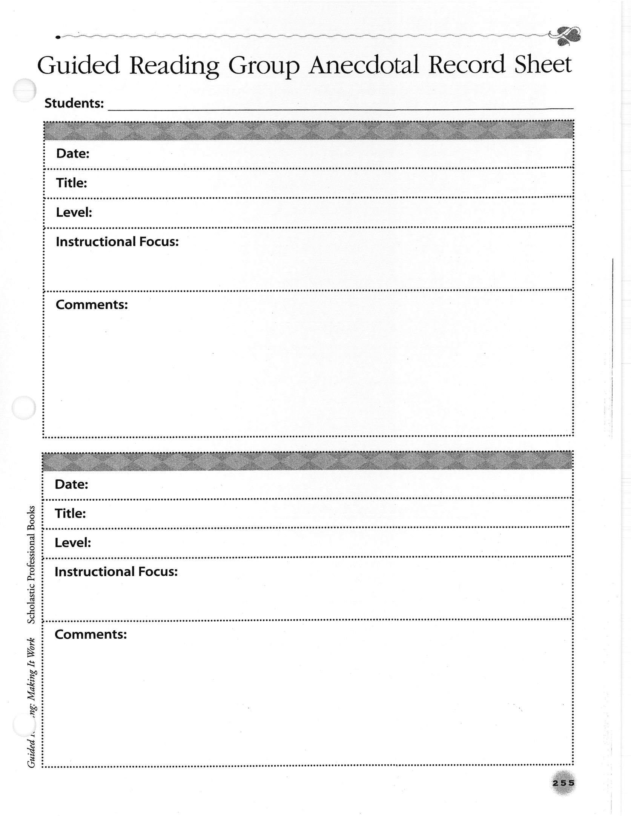Reflection/Self-Assessment:

I found that writing this lesson plan was more difficult than writing a mini-lesson. Although both lesson were generally that same amount of class time, I felt like so much more was needed in the guided reading lesson plan. With so much information to cover and go over, I felt a bit lost sometimes. However, I think I pulled it off; choosing the right content to review and placing everything at the right moment during instruction.

Firstly, I made sure to include draws for visual learners, auditory learners, picture smart learners, word smart learners, and people smart learners into the guided reading. Effective teaching integrates instruction for multiple intelligences. I do not want any students to feel disadvantaged or disheartened. An example of this is during word work. By incorporating the flash card dictionary, I made sure to appeal to picture smart learners who like to draw and create, as well as the learners with word smart intelligence that enjoy writing and vocabulary. Additionally, by having students pair up with shoulder partners during word work, I can give extra support to my ELL students who might need the help while appealing to people smart learners who enjoy group work. Furthermore, throughout the lesson there is inclusion of T-charts and pictures in the chapters to help visual learners. To help auditory learners, we discuss the book aloud before and after reading.
Context is a vital part to helping children develop language and literacy skills. Being able to use context clue to comprehend the story will allow students to engage effectively in collaborative discussions about what they have read. They will be able to form their own ideas about the content. Thusly, they will be able to pose questions and respond others’ remarks. I used modeling as a tool to teach kids how to use context clues in the beginning of the lesson. Research shows that comprehension is a key component to learning. After all, if readers can read the words but do not understand what they are reading, they are not really reading.

I chose to include a small focus on nonsense words to add phonics into my lesson. Studies have shown that the ability to decode nonsense words fluently is a great predictor of reading ability. This is because, I believe, it allows teachers to really see if students are recognizing written spelling patterns or just memorizing words. We know that even young children will pretend to read a word by memorizing it, but not really understand the building blocks of how a specific word is formed. By practicing with nonsense words, students also learn how to attack normal words by identifying letter formations and such.
Overall, I feel that my lesson plan incorporates effective research based teaching strategies that is both fun and enhances the students’ language and literacy development. In order for students to comprehend what they are reading, they need to decode words to derive meaning. They also need to be able to use context successfully so that they can fluently read. Although there is a spotlight on using context clues for comprehension, I was also able to hit upon phonics and vocabulary content as well. A well-rounded lesson appealing to multiple learners, which I think I achieved, is the most effective teaching tool.

